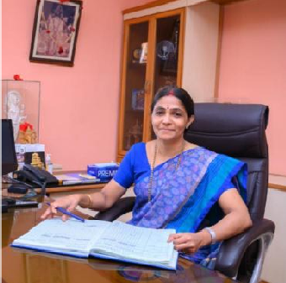

Dr. Mamatha K.V. MS (Ayu) PhD

Principal
S.D.M. College of Ayurveda & Hospital, Kuthpady, Udupi District

574118 Karnataka Profession and Positions
- Well known Obstetrician and Gynecologist with 25 years of experience.
- Head of the institute to the esteemed institution, SDM College of Ayurveda Udupi.
- Medical superintendent of SDM Ayurveda Hospital Udupi from the year 2018 to 2021.
- Served as a member of syllabus committee of CCIM at various levels
- Course writer and editor for AYUSH Nursing Course of Indira Gandhi Open University.
- Chairman, BOS (UG)
- Researcher in various research projects of VGST, RGUHS etc.
- Associated with many NGOs as a resource person in working with adolescent education and women’s health and delivered more than 250 talks on these areas for general public.

Educational Qualification

Degree | Year | Institution/ place | University
PhD | 2010 | NIA Jaipur | NIA Jaipur
MD (Ayu) | 1993 - 1996 | B H U Varanasi | B H U Varanasi
Certificate course & Diploma in Yoga | 1994 | B H U Varanasi | B H U Varanasi
BAMS (Gold medal) | 1993 | A.M.V. Hubli | Karnataka University

Awards and recognitions

- Gold medal in BAMS from Karnataka University, Dharwad.
- Awarded as “Young Scientist” in Kaumara 2006 International Seminar held at S DM College, Hassan.
- Awarded as “Outstanding alumni” by the alumni association of A.M.V Hubli in 2012.

Academic activities
- Guide for dissertation work of PG and PhD scholars in S.D.M College of Ayurveda & Hospital Udupi. Guided more than 35 PG dissertations and 4 PhD works.
- Participated as an invited guest speaker at various National and International seminars and workshops.

Researches and publications
- Completed a study on Garbhini Rasayana funded by RGUHS Bangalore.
- Awarded with a 60 lakhs centre of excellence (CESEM) project from the vision group of science and technology, Govt. of Karnataka.
- Completed a project of 13 lakhs from RGUHS funded by Dept. of AYUSH for the study on PCOS.
- Part of an International Project on Cervical Cancer running in 13 countries as a co PI with KMC Manipal.
- Functioned as chief organizing secretary, Resource person in various National and International seminars and published various scientific papers in national and international journals.

